**Interactive Game Development Project**

**(MET4332)EA**

Unity Project Report



| **Name:** | **Student ID:** |
| --- | --- |
| Lam Chi Him | 200539776 |
| Lee Chun Kit | 200192057 |
| Wong Hin Shun | 200041452 |
| Li Ka Ho | 200029672 |

**Class:** IT114206-2C

**Date:** 9th December 2021

Table of Contents

Introduction 1

Game Name 1

Genre 1

Description 1

Background story 1

Focus 1

Research 2

Concept 2

Core game idea 2

Pitch 2

Feature 3

Dynamic Environment 3

Tower Defense 3

Characters 4

Player Character: 4

Towers: 4

Schedule 5

Potential Difficulties 5

Equipment 5

Modeling 5

Level design 5

Division of responsibilities 6

Reference 6

# **Introduction**

## Game Name

Ultrace

## Genre

3D Racing game

## Description

Our game name is Ultrace. Our target groups are teenagers and car lovers. The player can control the car to race. Their goal is to reach the end within a limited time

## Background story

One day, Peter wants to break through to the end point in time, and his dream is to become a race car driver. He used his large sum of money to buy a racing track, and he practiced in it constantly.

# 

# 

# 

# **Focus**

Since Kinect game is not popular right now. The purpose of our idea is to promote Kinect games. Through this game, we want to let the players know the experience of the Kinect game. We want to promote Kinect game to let more people know the fun of Kinect game, Kinect game into the surface can detect the player's movement to carry out some action inside the game, for example, we are making a racing game, and the player needs to set the control of the corona dial, and twist left and right to control the defense of the car.

# **Research**

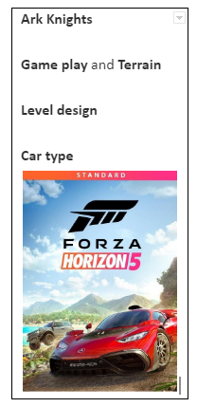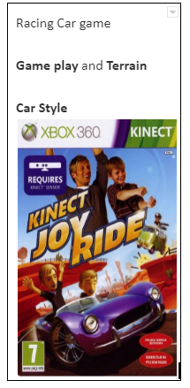

# **Concept**

## Core game idea

Our core gameplay concept is to let the player be inside the car, we will be able to use Kinect to control the direction of the car. Where the player can interact with the environment.

## Pitch

**Unconventional car racing game**

Interactive car racing game.

**Cars and scenes are very realistic**

We use some vehicles that are available in the real world, and the venue is somewhat similar to the real world. We make three large scenes for level 1 to 3, and have a lot of objects in the scene.

**Players need to go through the level in a limited time**

Players need to complete Level 1 to level 3 within 4 minutes so the player can win the game.

**Difference level design, car, obstacles, time char**

We design different and pretty environments for different scenes. For example, scene 3 is harder than scene 2 and scene 1.

# **Feature**

## Dynamic Environment

In the scene, we will intercept some real-world scenes, such as some houses, buildings, and even some seawater and so on. In addition, there will be some obstacles or some dynamic moving objects to obstruct the player racing. Players need to avoid them in order to reach the end point more effectively.

The car itself will have a blood bar, if the collision is too much or the life value reaches 0 will end the game, so the player needs to be careful to race.

## Time Racing

Each level has a time limit to reach the next level, and players need to reach the end point within the time limit to unlock the next level, and they can also keep updating their racing time. And there will be several cars for players to choose from, the venue can also choose their own, but players need to unlock all the levels before they can choose.

Equipment

This Project requires Leap motion to play and develop. Unlike mouse, keyboard and controller, the input of leap motion is more abstract. Furthermore, leap motion’s detection is more accurate to detect the player’s movement.

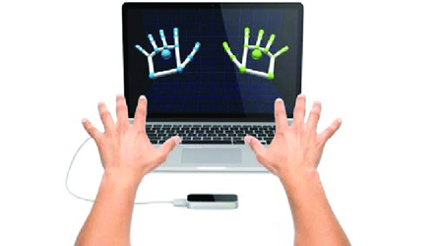

**How to control:**

1. The first control method is to use your fingers to control

* turn left → Overlapping the middle finger can make the vehicle turn left
* turn right → Overlapping thumbs can make the vehicle turn right
* brake → Overlapping the index finger can make the vehicle brake

2. The second control method is to use gestures to control

* turn left → Overlapping the middle finger can make the vehicle turn left
* turn right → Overlapping thumbs can make the vehicle turn right
* brake → Overlapping the index finger can make the vehicle brake

# **Characters**

## Player Character:

The player character is a pair of giant hands floating in the air.

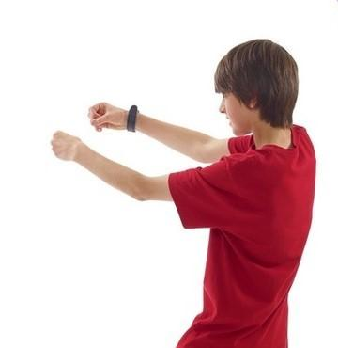

## Car:

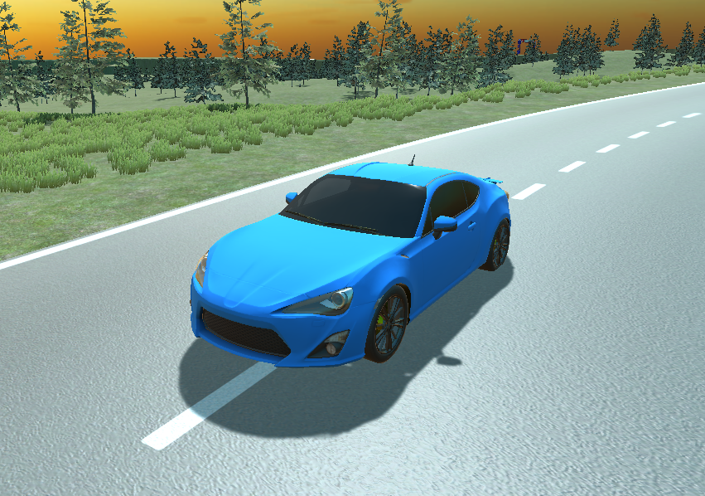

It is an all-blue AR-8 model vehicle with comprehensive performance.

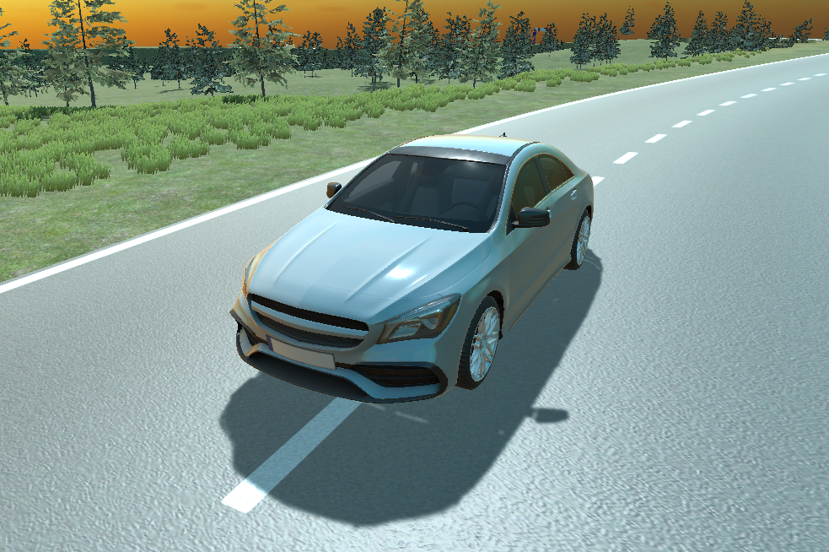

It is a better car when turning, the color is all silver

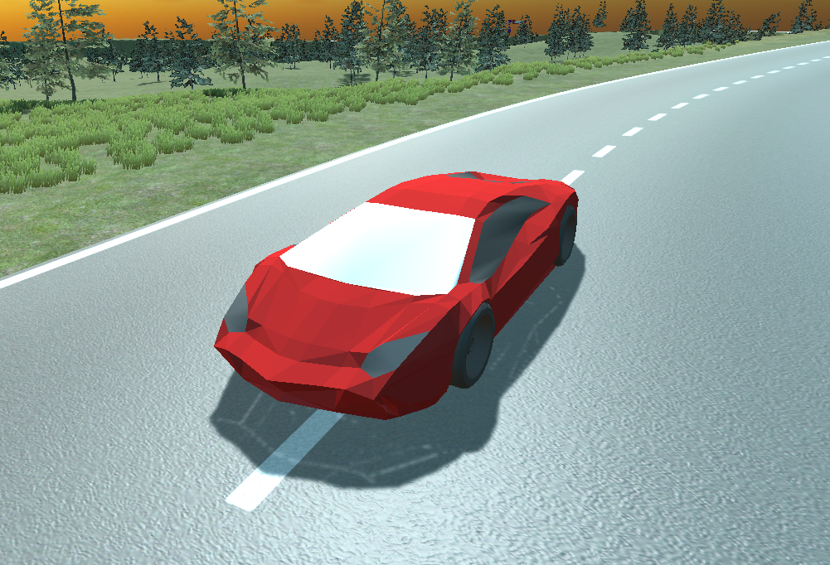

It is an all-red Lamborghini with very high performance in terms of speed.

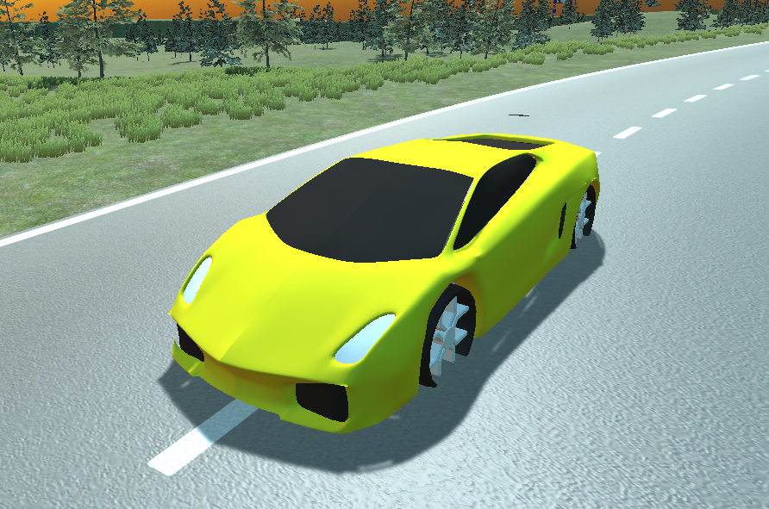

It is an all-yellow Lamborghini and he pays great attention to speed.

**UI Design**

1. Main Menu

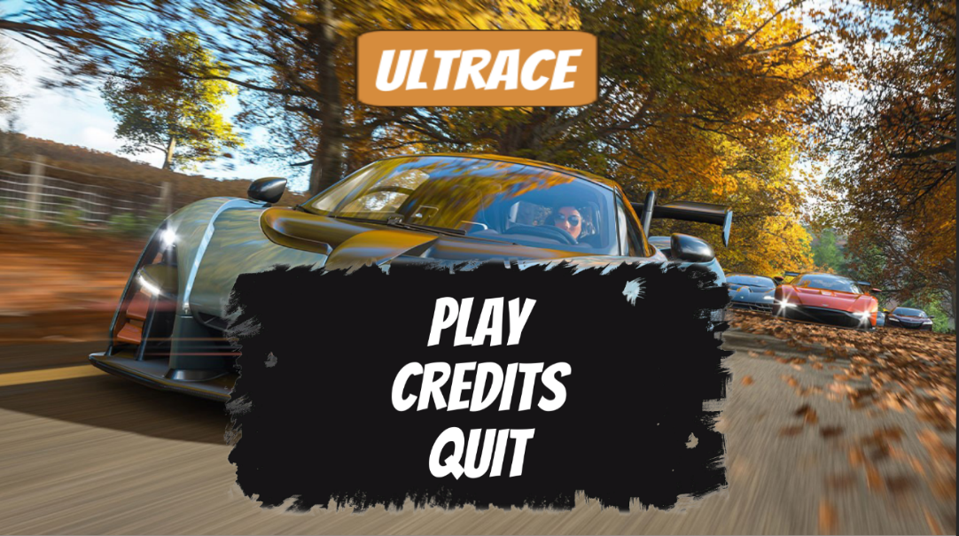

1. Credits Screen

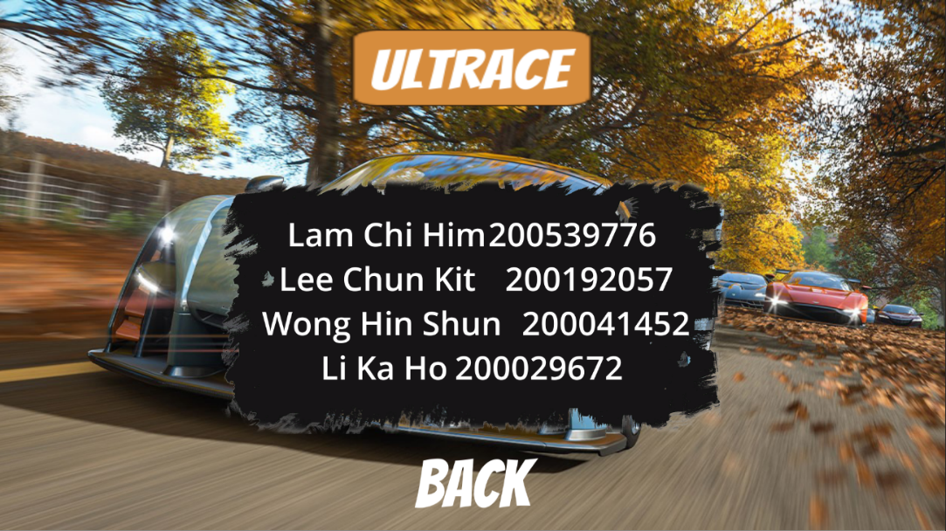

1. Select Menu

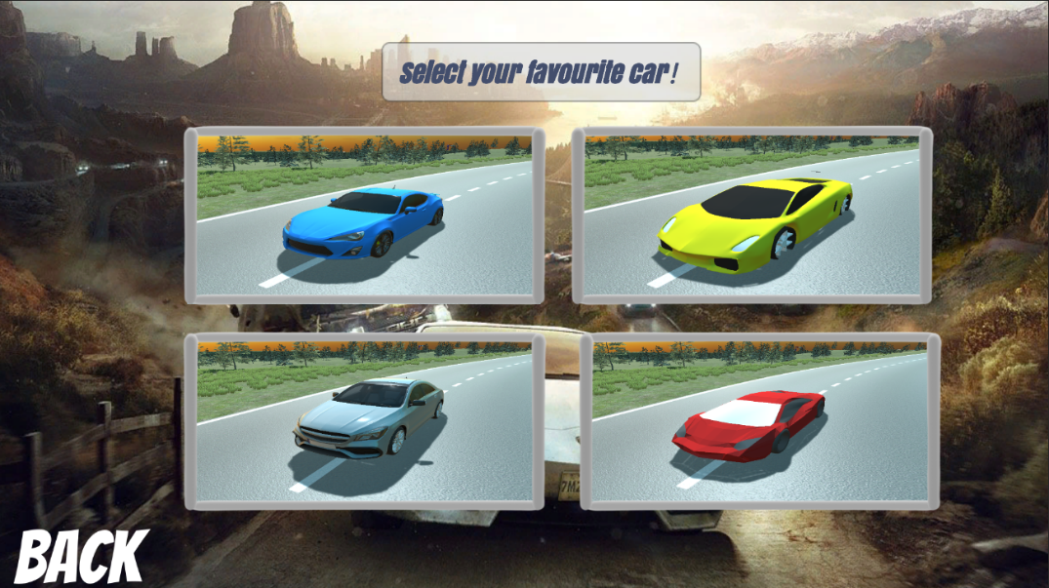

4. Win Screen



**Game Design**

1. **Time**



We can see the above time to show the player their time for each game, and the time will continue to the next level, player needs to reach the level within four minutes.

1. **Mini map**

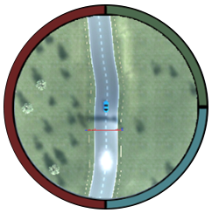

We can see the mini map in the lower left corner to show the player their location and nearby roads, so that the player can know the information on the map.

1. **Car Speedometer**

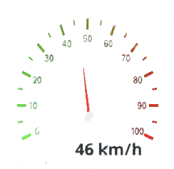

We show a speedometer to the player, so that the player can immediately clear and see what their current speed is, so that the player can know the need to slow down when turning, and so on.

1. **Starting Line**

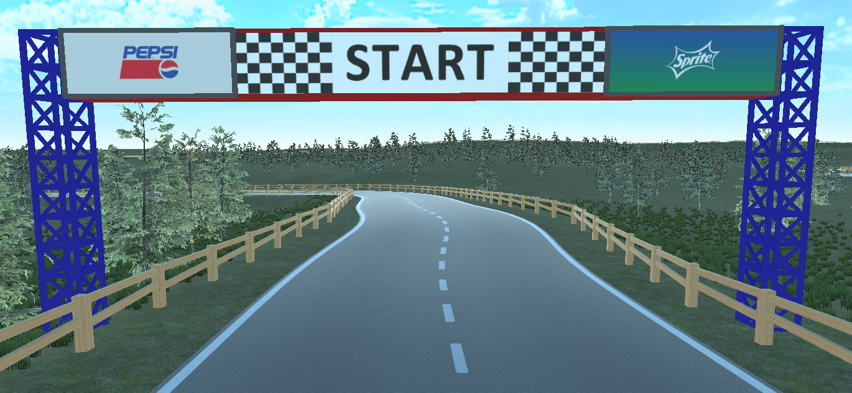

1. **Ending Line**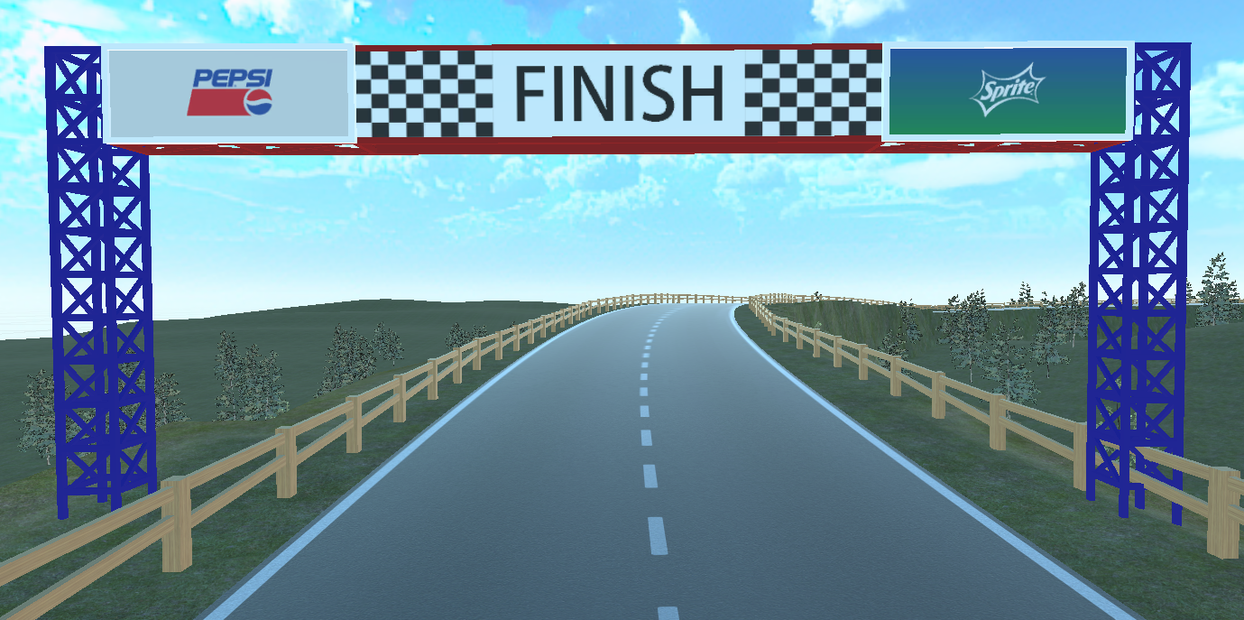

**Level Design**

1. Draft Level 2 Design



2. Draft Level 3 Design

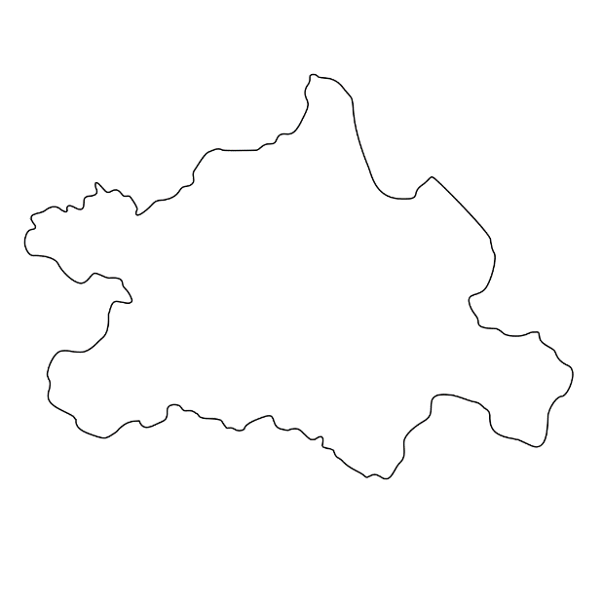

Scene 1

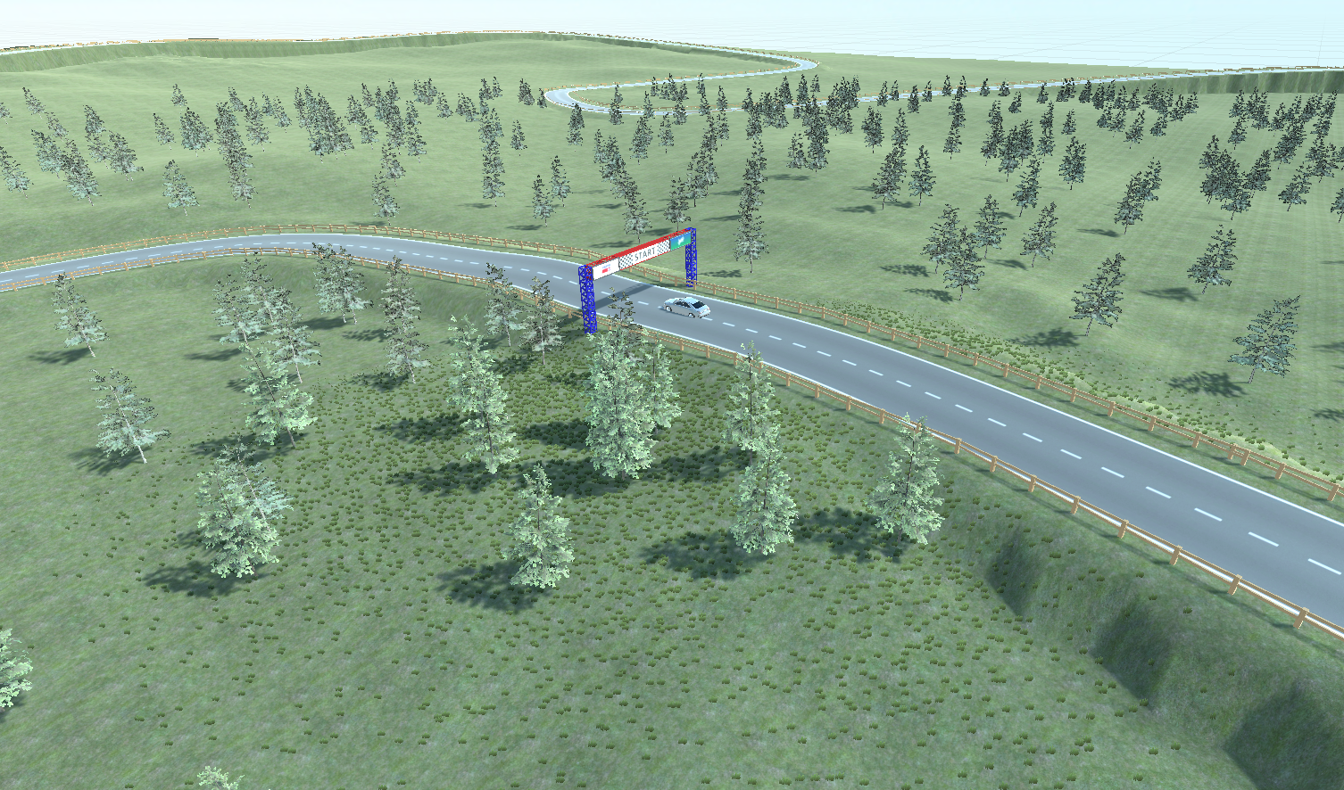

Scene2

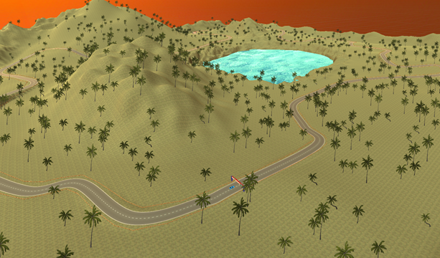

Scene3

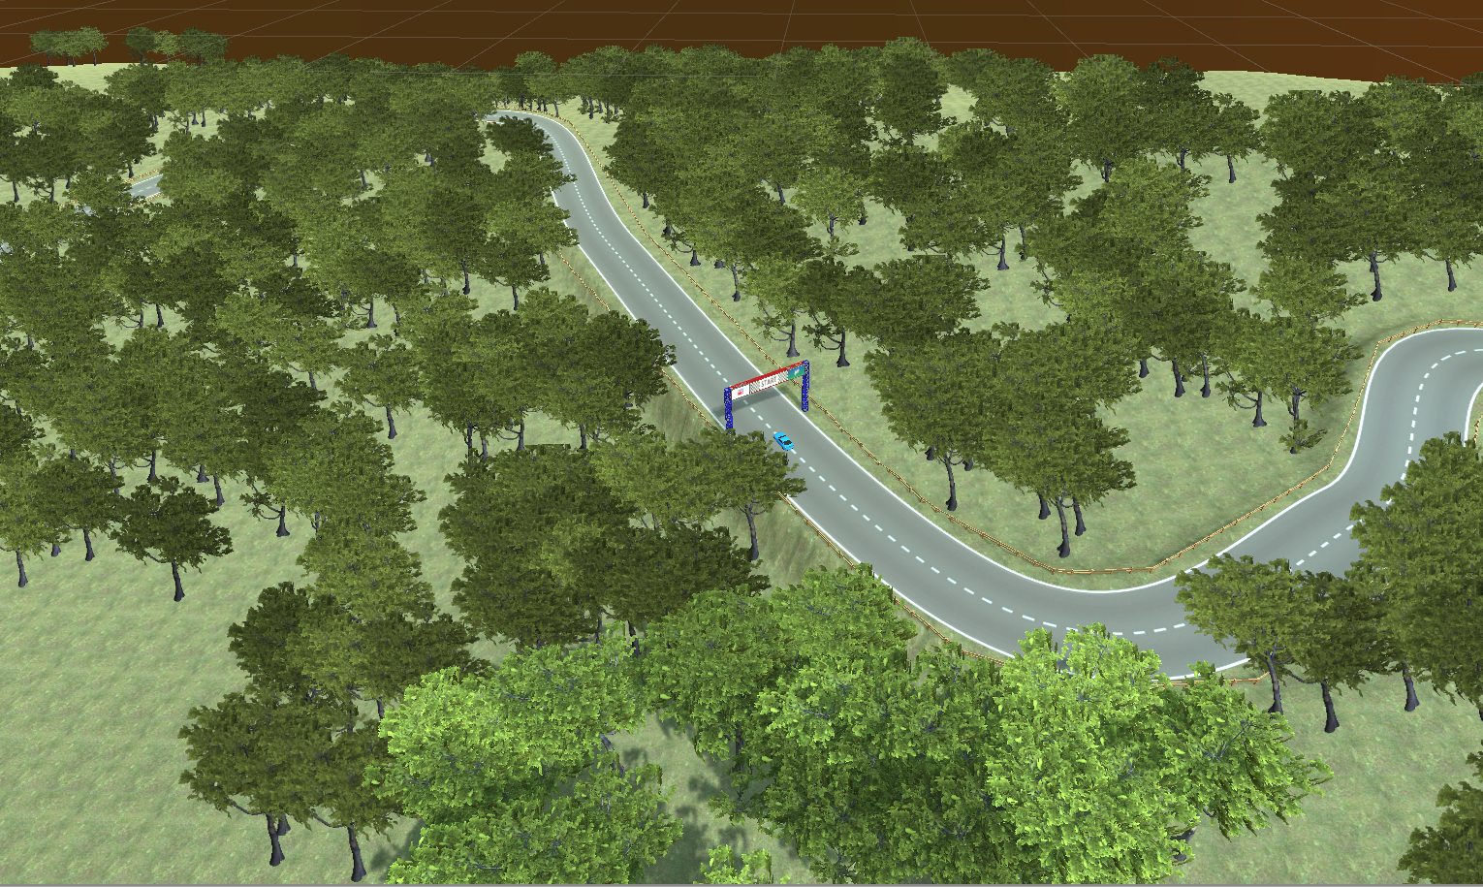

**Audio Effect Design**

As for the car audio, we use the engine sound style as four channels. For the four channels, we have four audio clips, lowAccelClip, lowDecelClip, highAccelClip and highDecelClip. I public sound effect data to give us to adjust sound level.

In real life, cars have the engine sound, Wheel sound, stop sound and start sound. Car engine sound, I categorize it into four stages, according to our speed, driving speed, and then adjust the data, under what circumstances will play our four kinds of audio, so that our car has the same sound effect as a real car.

**Game Flow Programming**

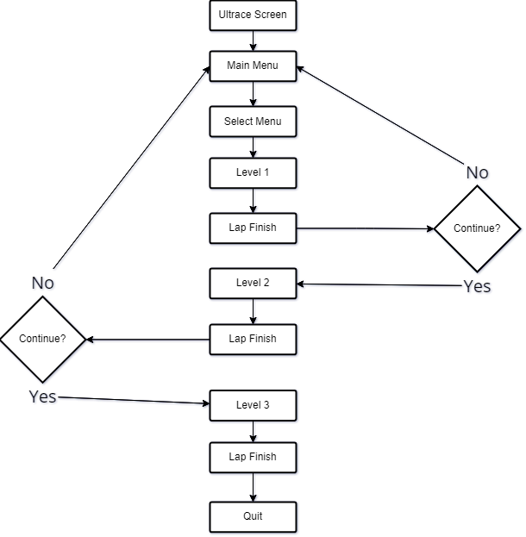

# 

**Game Play Programming**

**ButtonOption**

# **Reference**

1. Forza Horizon 5 : Car Racing game

<https://www.microsoft.com/zh-hk/p/forza-horizon-5/9nnx1vvr3knq?activetab=pivot:overviewtab>

1. KINECT JOYRIDE

<https://www.youtube.com/watch?v=NPYR6KGEtvE>

End of Proposal